GRASP

Installation Manual Step-By-Step v1.3 for GRASP Installer version 1.0.12

Manual version 1.3

GRASP Reporting version 1.3.0

GRASP Designer version 1.2.0

GRASP Mobile version 1.1.4

November, 2015

By

Information and Knowledge Management Unit, UN WFP Palestine Country Office

November, 2015

**Revision History**

|  |  |  |  |
| --- | --- | --- | --- |
| **Date** | **Description** | **Author** | **Comments** |
| 3 March, 2015 | Version 1.0 | Saad Mansour | First Release. |
| 3 March, 2015 | Version 1.0 | George Mu’ammar |  |
| 3 March, 2015 | Version 1.0 | Irene FERRARI |  |
| 10 March, 2015 | Version 1.1 | Saad Mansour | Add section 3.5.1 How to Create a Scheduler Task to Process the Incoming Forms in GRASP Reporting. |
| August, 2015 | Version 1.2 | Saad Mansour | Update GRASP Components Versions. |
| November, 2015 | Version 1.3 | Saad Mansour, Claudia Alawi |  |

Table of Contents

1. Introduction

2. GRASP System Requirements

3. Install GRASP Step-By-Step

3.1 Run GRASP Installer version 1.0.12

3.2 GRASP Agreement

3.3 GRASP Requirements

3.4 GRASP Database Configuration

3.5 Install GRASP Reporting (web application)

3.5.1 How to Create a Scheduler Task to Process the Incoming Forms in GRASP Reporting

3.6 Install GRASP Designer

3.7 Verify GRASP Installation

3.8 Run GRASP Designer System

3.9 Install GRASP Mobile

APPENDICES

APPENDIX 1: Install Microsoft .NET Framework

APPENDIX 2: Install JAVA Version 7

APPENDIX 3: Enable Microsoft SQL Server TCP/IP protocol

APPENDIX 4: Move GRASP Reporting Location Path

APPENDIX 5: Enable 32-bit Applications in IIS

APPENDIX 6: Open GRASP Reporting Port

APPENDIX 7: Install Microsoft SQL Server and Management Studio

APPENDIX 8: Set Folder Permissions for IUSR

APPENDIX 9: Change GRASP Reporting Web Configuration file Properties

# **Introduction**

This manual provides a step-by-step procedure for installing the new version of the three GRASP components (Designer, Reporting, and Mobile) using GRASP Installer version 1.0.12. Also, this manual covers the prerequirments installations and most of the errors that you may face during the installation wizard. The new GRASP Installer described in this manual done almost everything for you automatically in a simple wizard.

**Note:** the latest version of this manual can be found from this link: [GRASP Installation Manual Step-by-Step](https://docs.google.com/document/d/1FgmoGUI685UQedLskPINuu3-K9eK_McmJ_RfOQlO4BQ/edit).

To ask for any support, please send to the following emails:

* George MUAMMAR: [george.muammar@wfp.org](mailto:george.muammar@wfp.org)
* Saad MANSOUR: [saad.mansour@wfp.org](mailto:saad.mansour@wfp.org)
* Claudia ALAWI: [claudia.alawi@wfp.org](mailto:claudia.alawi@wfp.org)

You can download this document as a Microsoft Word by click on **File** menu, select **Download as**, then click **Microsoft Word (.docx)**.

# **GRASP System Requirements**

Below is a list of the required frameworks and tools to run GRASP:

* **GRASP Installer:**
  + To run GRASP Installer you need to install Microsoft .Net Framework version 4.0 or above.
* **Database:**
  + Microsoft SQL Server 2008 R2 (recommended, and you can use Express Edition) or above.
* **GRASP Designer:**
  + To run GRASP Designer you need to install JRE 7 (Java SE Runtime Environment).
* **GRASP Reporting:**
  + Microsoft ASP.Net 4.5
  + IIS 7
* **GRASP Mobile:**
  + Android version 4.x and above (the app may work on lower versions but it is not supported).

# **Install GRASP Step-By-Step**

This section provides a step-by-step procedure for installing the new version of the three GRASP components (Designer, Reporting, and Mobile) using GRASP Installer version 1.0.12.

## ***3.1 Run GRASP Installer version 1.0.12***

1. Download the GRASP Installation Package **“GRASPInstaller_v112 with Installation Manual.zip”**.
2. Extract **“GRASPInstaller_v112 with Installation Manual.zip”** zipped file.
3. Before you start the installer, check your user account folder, if there is already a folder called “**FrontlineSMS**”, delete this folder. Ex: C:\Users\Administrator\FrontlineSMS
4. Check you IIS, if you have a virtual directory called “**GRASPReporting**”, remove it if you don’t need it, as the installer will create one with “**GRASPReporting**” name.
5. Open **GRASPInstaller_v112** folder, and right-click on the **“GRASP_Installer.exe”** setup file and select **“Run as Administrator”.**

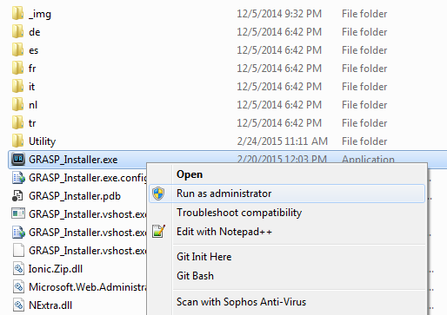

1. If the .NET Framework is not installed on your machine, you will see the below message. Please, refer to **APPENDIX 1: Install Microsoft .NET Framework** to install the .NET Framework, and then try again:

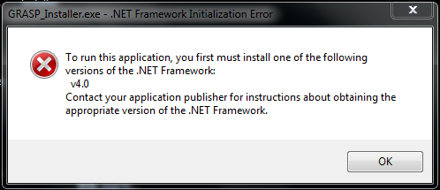

1. If you see the following warning, don’t worry, just click on **“Run”** button.

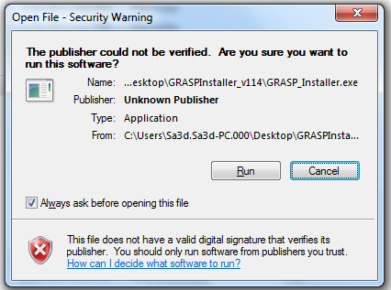

## ***3.2 GRASP Agreement***

1. Read the GRASP Agreement, and then click on **“I agree”** buttonto agree on the terms and conditions of using GRASP.

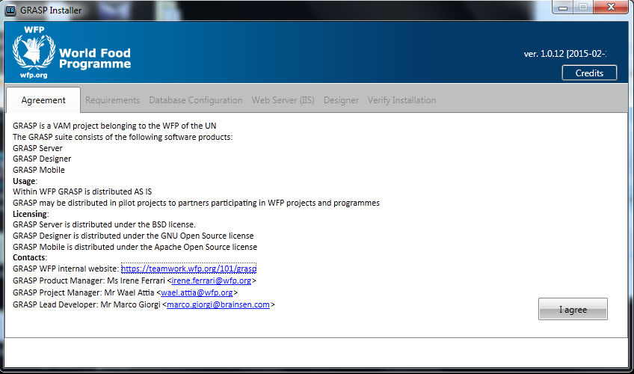

## ***3.3 GRASP Requirements***

1. You are now in the **“Requirements”** tab, click on **“Start System Requirement Check-up”** button to automatically check that all prerequirments to run GRASP are installed correctly.

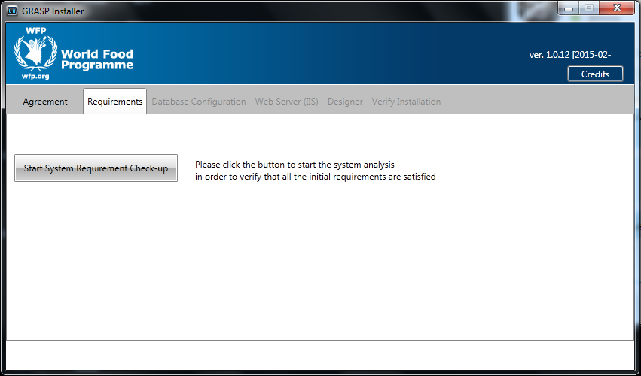

1. If JAVA version 7 is not installed on your machine, you will see the below message. Please, refer to **APPENDIX 2: Install JAVA Version 7**, to install JAVA version 7, and then try again:

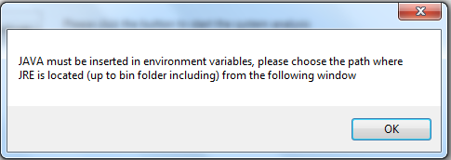

1. Then, the following popup will appear to automatically install IIS version 7 (Internet Information Services) and enable all its features.

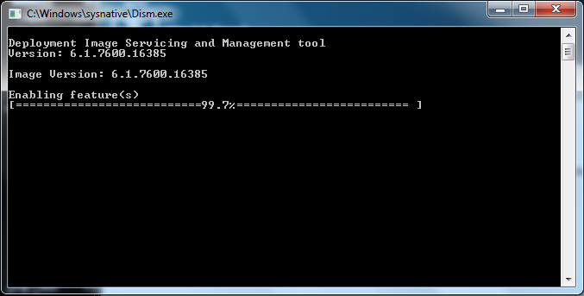

1. Then, the following popup will appear to confirm the installation of IIS version 7.

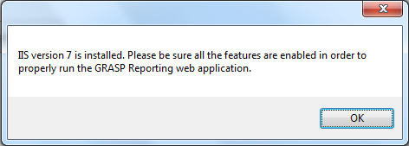

1. Optional Step, to make sure that all IIS features are enables, go to Control Panel > Programs > Programs and Features, click on **“Turn Windows features on and off”** and check that all IIS features are enabled. If you find unchecked features, please check them all.

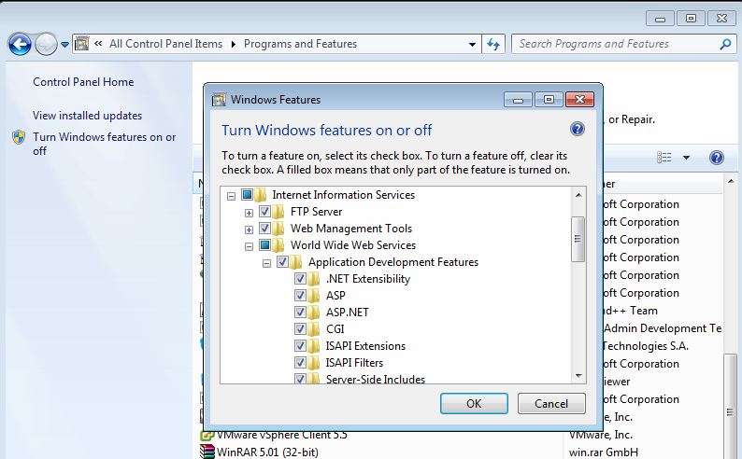

1. Another popup will appear to automatically install ASP.NET.

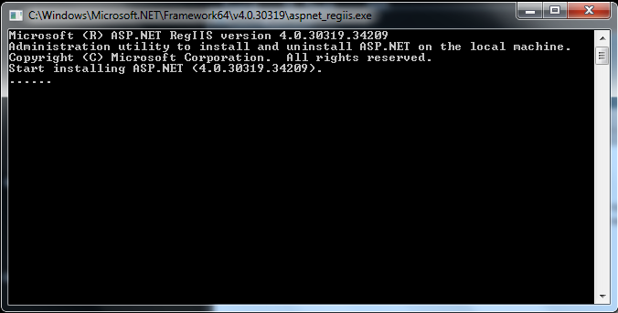

1. After checking the requirement is completed, the GRASP Installer shows **“Check completed!”** message with the installed java version, java home path, and IIS status. If you don’t see the three requirements as shown in the below image, please install the missing requirements (ex: Java 7) and click on **“Start System Requirement Check-up”** button again.

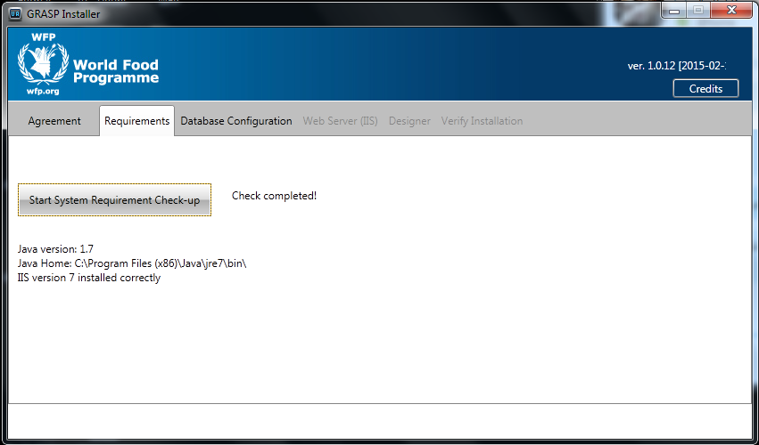

## ***3.4 GRASP Database Configuration***

1. Now, go to the next tab **“Database Configuration”** to create or select the GRASP database.

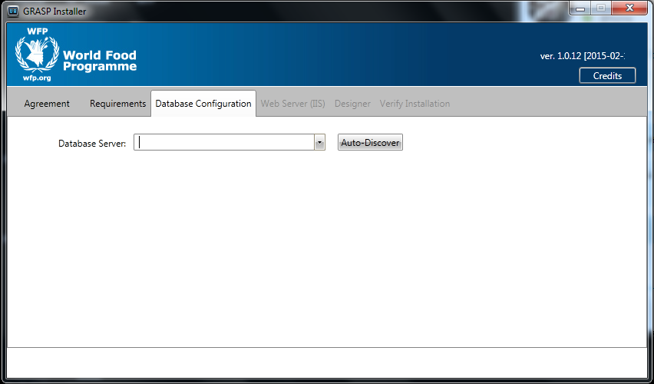

1. Click on **“Auto-Discover”** button, the installer will auto discover the database servers on the network. If no MS SQL Server are found, GRASP Installer will show a messgae says **“No Microsoft SQL has been found!”**. In that case, you have to enable **TCP/IP** protocol. Please, follow **APPENDIX 3: Enable Microsoft SQL Server TCP/IP protocol**.

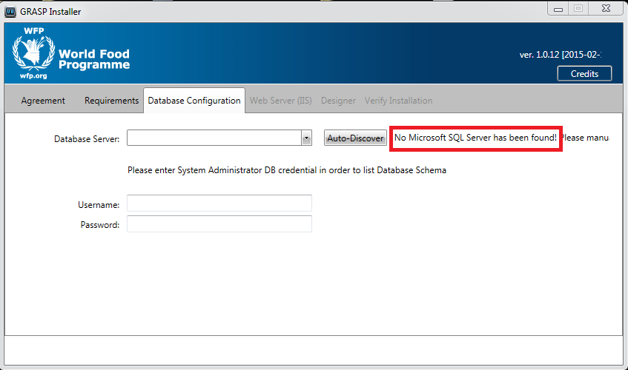

If the SQL Server TCP/IP is enabled, the installer will auto discover the database servers on the network.

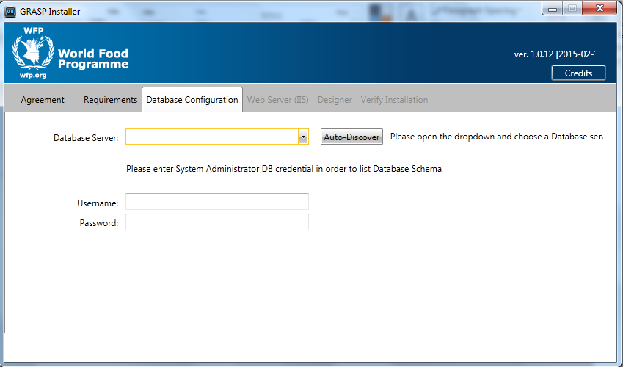

1. From the **“Database Server”** dropdown list, select your database server name.

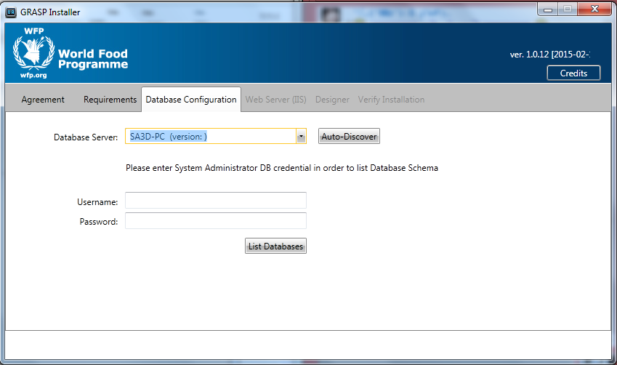

1. If you don’t have a GRASP database, or you already have one put you want to create a new clear one, please follow 4.1 steps. Otherwise, if you have an existing GRASP database and you want to continue using it with this new GRASP version, please follow 4.2 steps.
   1. Option 1: These steps are for creating a new GRASP database:
      1. If you already have a database named GRASP, and you want to create a new clear one. First, it is highly recommended to take a backup of your database before renaming or deleting it (for more information of how to backup a database in SQL Server 2008, please visit this link: [How to Back Up a Database](https://msdn.microsoft.com/en-us/library/ms187510%28v=sql.105%29.aspx)), or at least GRASP Designer provides you the ability to export your data, for example: Forms, Contacts, and Messages. And then, you can import them in the new version. After you take a backup, you have the following options:
         1. Rename the old database and its physical files. For more information of how to rename a database in SQL Server 2008, please visit this link: [How to Rename a Database](http://sqlandme.com/2011/08/02/sql-server-renaming-database-and-physical-database-files/).
         2. Delete the old database and its physical files. For more information of how to delete a database in SQL Server 2008, please visit this link: [How to Delete a Database](https://technet.microsoft.com/en-us/library/ms189278%28v=sql.105%29.aspx).
      2. Enter the database system administrator’s username and password, and then click on **“List Databases”** button to list all databases.

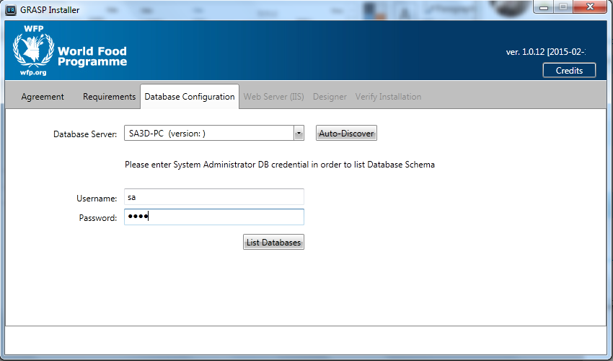

* + 1. If you don’t already have a database named GRASP, the following popup will appear, click on **“Yes”** button to make the installer automatically creates a new GRASP database.

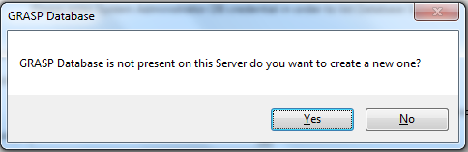

* + 1. If you clicked yes, the following message will appear to confirm that the GRASP database has successfully created. Click on **“OK”** button.

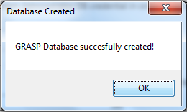

* + 1. Optional Step: if you open MS SQL Server Management Studio, you will find that GRASP Installer automatically created the GRASP database.

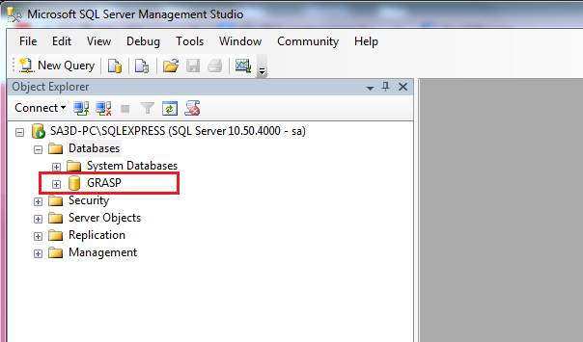

* + 1. The created GRASP database will automatically selected as shown below.

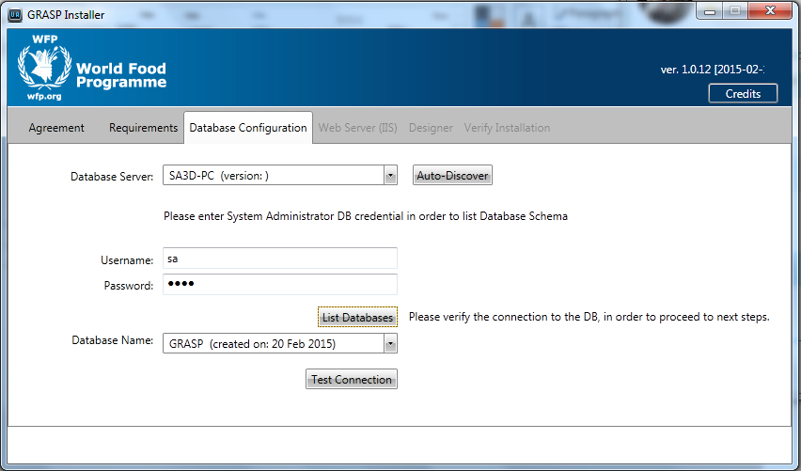

* 1. Option 2: These steps for selecting an existing GRASP database with this new GRASP version:
     1. First, you need to update your existing GRASP database (this step is recommended to done by a database administrator or an IT person). The update depends on your current GRASP version. Check your GRASPReporting version as shown below:

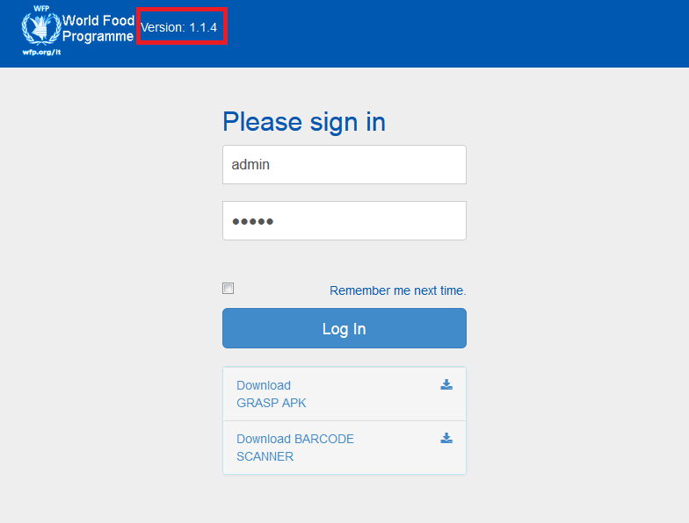

* + 1. If your version is **1.1.3**, then you have to run the script file under folder “**Utility\SQLDbScripts\UpdateToV1.1.4**” and then the script file under folder “**Utility\SQLDbScripts\UpdateToV1.2.3**”.

If your version is less than **1.1.3**, then you have to run multiple scripte files, find them under “**Utility\SQLDbScripts”** folder. There are four folders **UpdateToV1.1.2**: to update to version 1.1.2, **UpdateToV1.1.3**: to update to version 1.1.3, **UpdateToV1.1.4**: to update to version 1.1.4, and **UpdateToV1.2.3**: to update to version 1.2.3. Run the script files in order, for example: run scripts in folder UpdateToV1.1.2, then UpdateToV1.1.3, then UpdateToV1.1.4, then UpdateToV1.2.3

* + 1. Select your existing GRASP database from the **Database Name** drop down list.

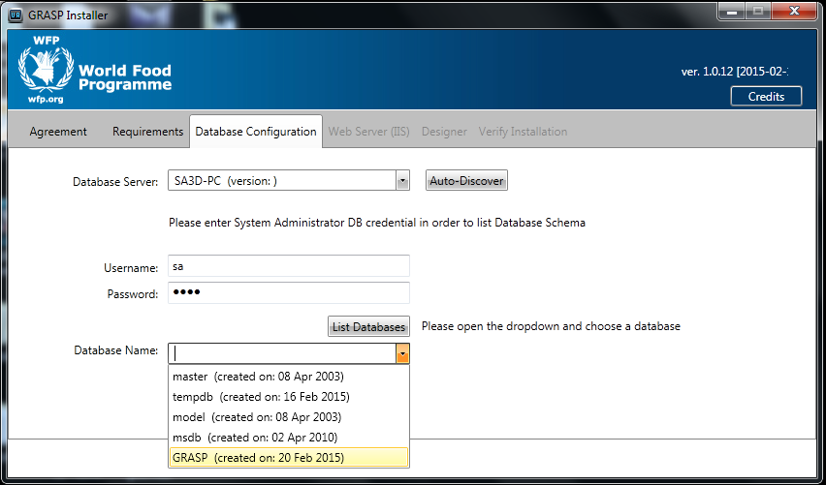

1. After creating or selecting the GRASP database, click on **“Test Connection”** button. If the installer can connect to the database, it shows “**Connection OK!**” message. If it shows **Connection Failed!** message, make sure of the username and password, if they are correct, then refer to **APPENDIX 3: Enable Microsoft SQL Server TCP/IP protocol**.

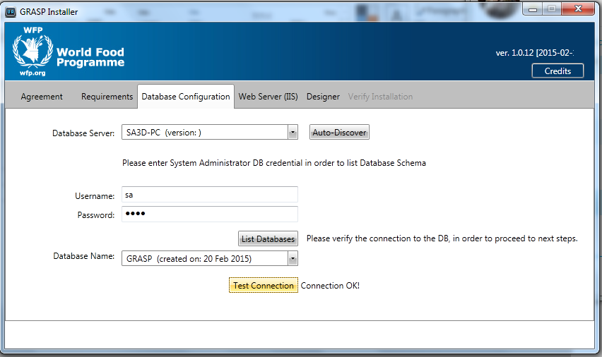

After you have tested the database connection, the next two tabs will be enabled. The first tab is **Web Server (IIS)** for installing GRASReporting system, and the second tab is **Designer** for installing GRASPDesigner system. Please, continue with the following sections.

## ***3.5 Install GRASP Reporting (web application)***

This section provides the steps to install GRASP Reporting system (web application).

1. After you have completed the steps in the previous section, go to **“Web Server (IIS)”** tab to install the GRASP Reporting System.

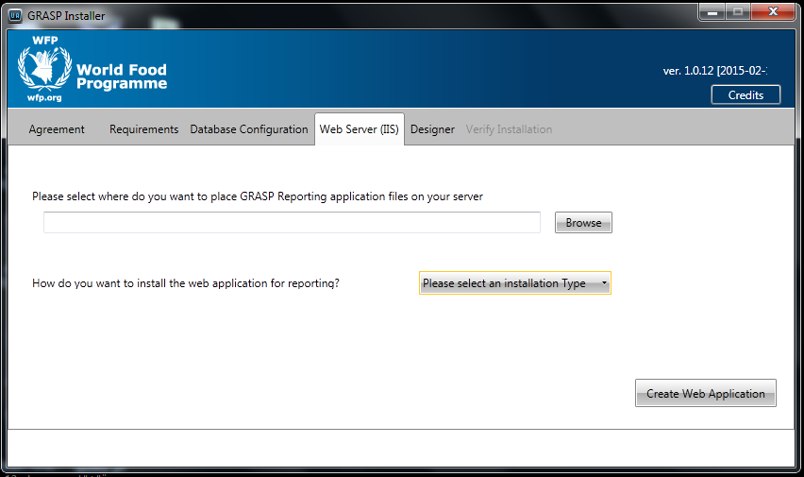

1. First, browse where do you want to place the GRASP Reporting files on your server.

**Important Note:** be careful when you select the path of GRASP Reporting system, since this is the server side system, which includes the **GRASPImage** and **ResponseFiles** folders where the server saves all the images and forms sent from mobile devices or uploaded via Reporting. Therefore, make sure to select a path where you have enough storage space. Anyway, you can move the Reporting folder later, please refer to **APPENDIX 4: Move GRASP Reporting Location Path**.

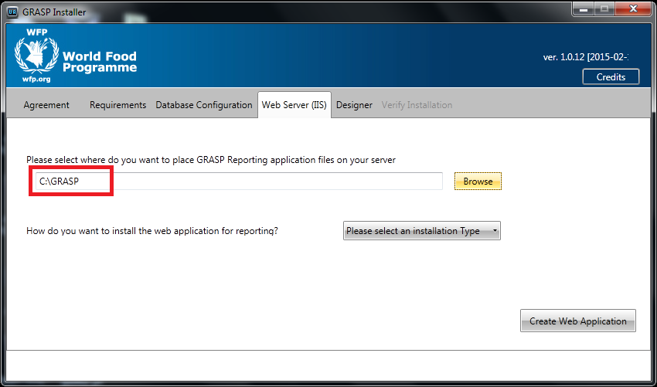

1. Now, select the installation type of GRASP Reporting under the IIS web server. Here, you have two options. The first option, is the **Virtual Directory** (Recommend option). The second option, is the **Web Site**, if you want to install it to different port than the default port number 80. Before you create the GRASP Reporting, make sure to remove or rename an existing web application with name **GRASPReporting**.
   1. Option 1: **“Virtual Directory”** type (recommended option):
      1. From the first drop down list, select **“Virtual Directory”** type.

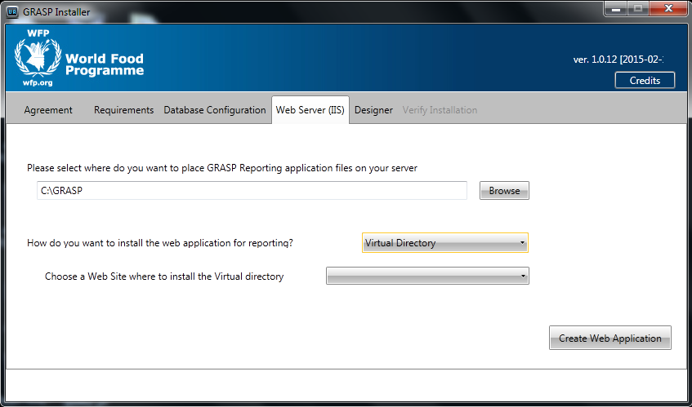

* + 1. From Sites drop down list, select the site where you want to install The GRASP Reporting Virtual Directory. The default option is **“Default Web Site”**.

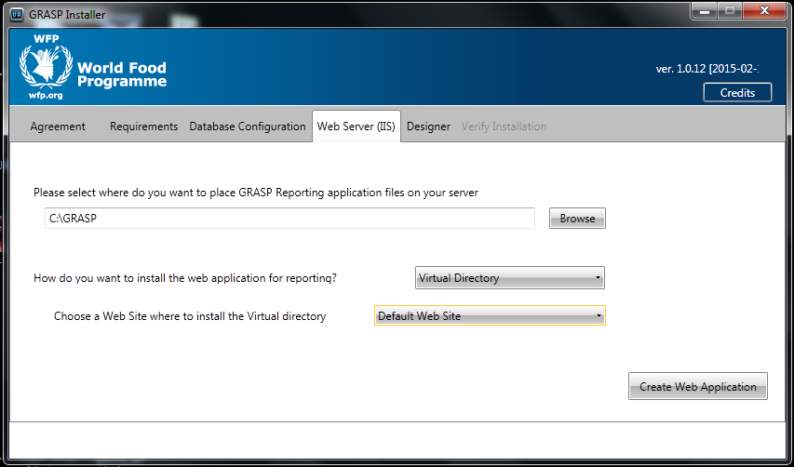

* + 1. Click on **“Create Web Application”** button to create the GRASP Reporting wep application under IIS web server.

After a while, a popup message will appear to inform you that the virtual directory has successfully created.

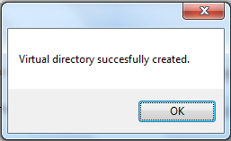

If you see the below error message, check if there is an already application called **GRASPReporting** in IIS, remove or rename it, then try again:

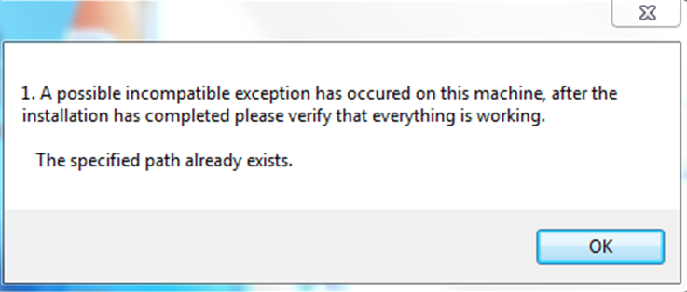

* + 1. Optional Step: now, if you open the IIS Manager you can find the created web application with name **“GRASPReporting”** and a **GRASP Reporting shortcut** is cerated in your desktop, as shown in the below pictures.

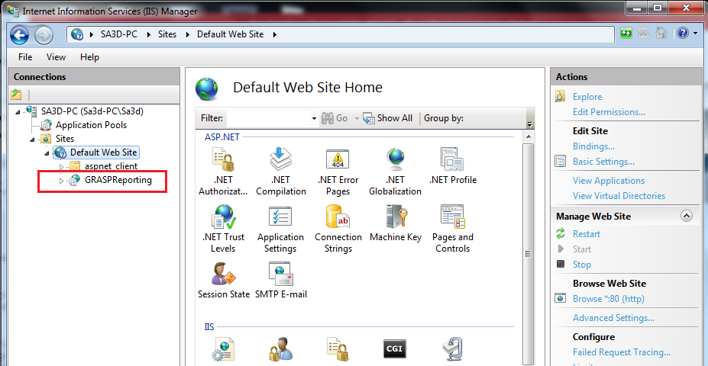

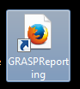

* + 1. Another popup message may appear, which tells you to enable 32-bit application pool.

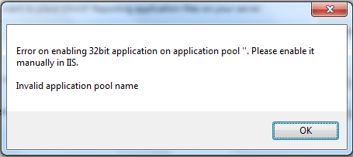

You can forget about this message, except if you face the below error when you try to run GRASP Reporting.

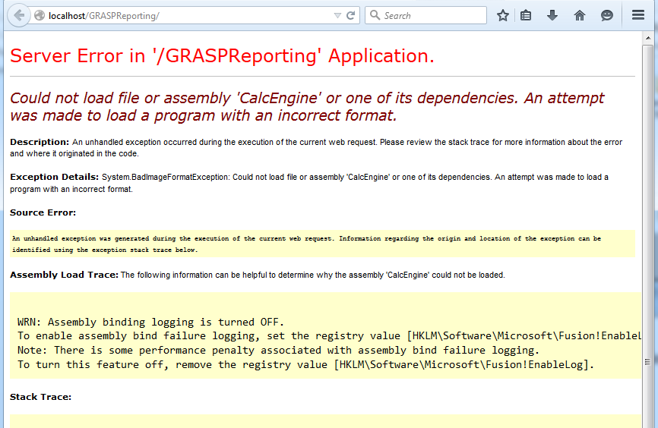

* + 1. To solve that error, you have to enable the 32-bit application pool. Please, refer to **APPENDIX 5: Enable 32-bit Applications in IIS**.
  1. Option 2: **“Web Site”** type, to install it to a specific port (other than port 80):
     1. From the First drop down list, select **“Web Site”**.
     2. The **“on port”** field appears with the default value **80**. If you want to install it to another port, change the port number (note that if you change the default port 80, you have to enter that port number in the settings of GRASP Mobile).

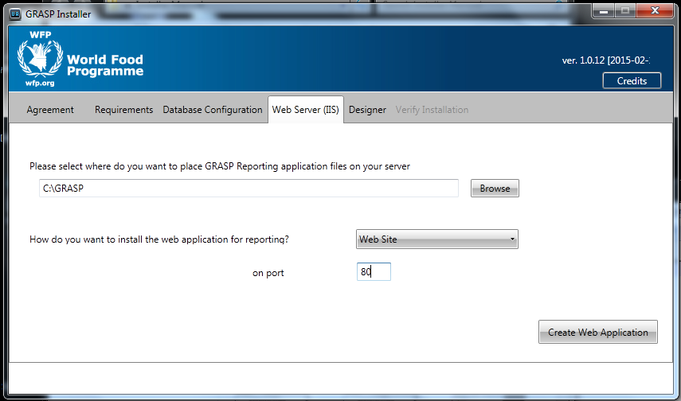

### **3.5.1 How to Create a Scheduler Task to Process the Incoming Forms in GRASP Reporting**

This subsection describes how to create a Scheduler Task to process the incoming forms from GRASP Mobile to GRASP Reporting:

1. Go to **control panel** > **System and Security** > **Administrative Tools** > open the **Task Scheduler**.
2. From the left pane, select the folder where you want to create the Task in or create a new folder.
3. From the right pane, click on **Create Task**.
4. In the General tab, enter the task **Name** (ex: GRASPProcessForms), and **Description** (ex: Schedule task to process incoming forms in GRASP Reporting.).
5. In the **Security Options** group, click on **Change User or Group** button. In the **Enter the object name to select** text area, enter “**system**”, then click on **Check Names** button to check that the entered name is correct, then click **OK**.

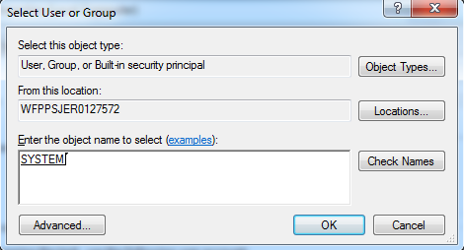

1. At the bottom, from the **Configure for** drop down list, select your server operating system.

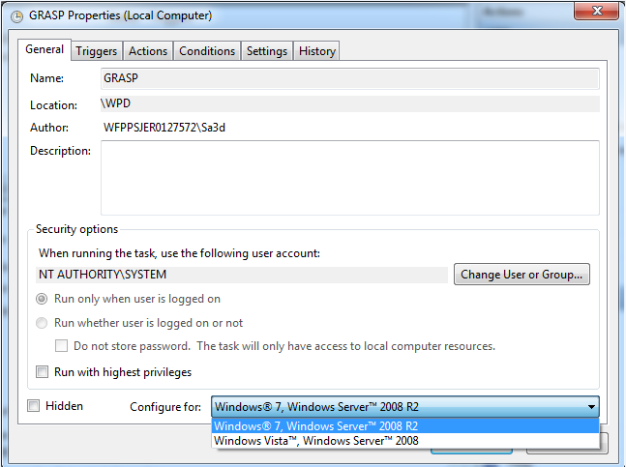

1. Go to **Actions** tab, click on **New** button.
2. In the **New Action** popup, from the **Action** drop down list, select **Start a program** item.
3. In the **Settings** group, in the **Program/Script** text box, enter “**powershell.exe**”. And in **Add arguments (optional)** text box, enter **-command "(new-object system.net.webclient).downloadstring('http://localhost/GRASPReporting/ProcessIncomingResponses.aspx/?method=pif')"** . Then, clock **OK**.

**Note**: in **Add arguments (optional)** text box, you may need to change the localhost to your server IP address, and if the virtual directory name of your GRASP Reporting web application is not GRASPReporting, then change it.

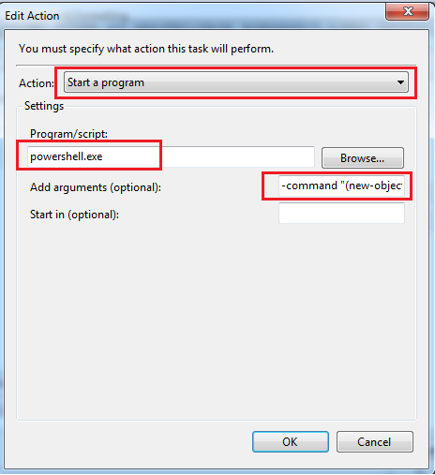

1. Go to **Triggers** tab, here we want to add two triggers. First one, Schedule trigger to run each period of time (ex: each five minutes). The second, Idle trigger to run when the server becomes idle.
2. To create the schedule trigger, follow the following steps:
   1. Click on **New** button, from the **Begin the task** drop down list, choose **On a schedule**.

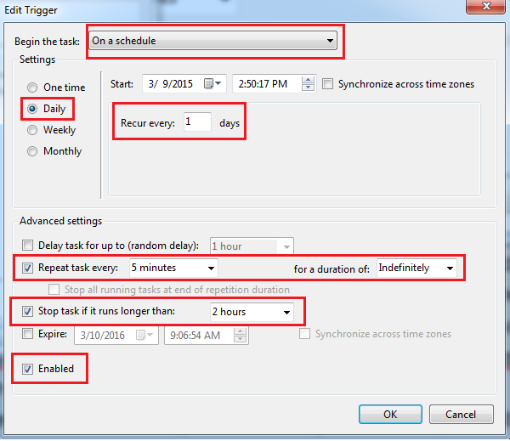

* 1. In the **Settings** group, choose **Daily**, and in **Recur every** text box, enter **1**.
  2. In the **Advanced settings** group, select the **Repeat task every** check box and choose 5 minutes (you can select another period like 30 minutes, depends on how much users of GRASPMobile application send forms to GRASPReporting). And, in the **for a duration of** drop down list, select **Indefinitely**.
  3. Optional, In the **Stop task if it runs longer than** drop down list, select **2 hours**.
  4. Select the **Enabled** check box (it may already selected).
  5. Click **OK**.

1. To create the idle trigger, follow the following steps:
   1. Click on **New** button, from the **Begin the task** drop down list, choose **On idle**.

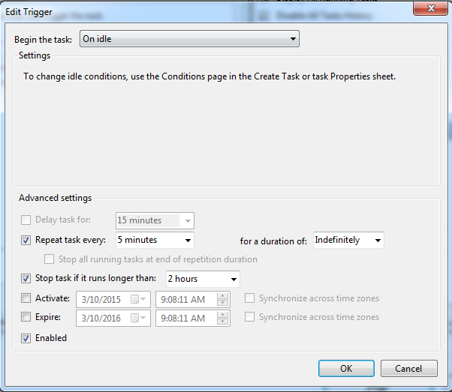

* 1. In the **Advanced settings** group, select the **Repeat task every** check box and select 5 minutes (you can select another period like 30 minutes, depends on how much users of GRASPMobile application send forms to GRASPReporting). And, in **for a duration of** drop down list, select **Indefinitely**.
  2. Optional, In the **Stop task if it runs longer than** drop down list, select **2 hours**.
  3. Select the **Enabled** check box.
  4. Click **OK**.

1. Later on, to make sure that the task is running correctly, you can go to **History** tab and check all the stages (ex: triggered, started, completed) of each run.

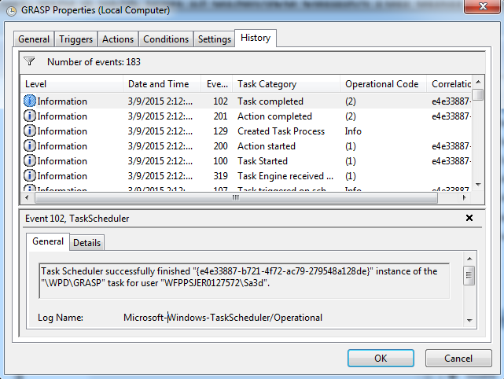

## ***3.6 Install GRASP Designer***

1. After you have finished installing the GRASP Reporting, go to the **“Designer”** tab.

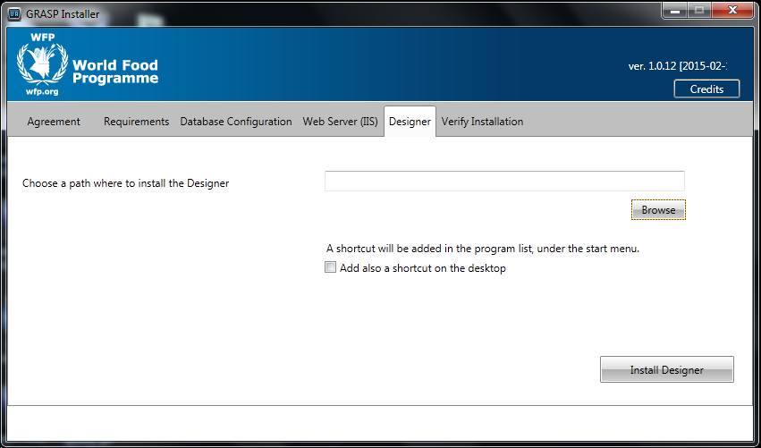

1. Browse the path where you want to install the Designer files (it is recommended to use the same path of Reporting, for example to put both of them under **C:\GRASP** as shown in the below picture).

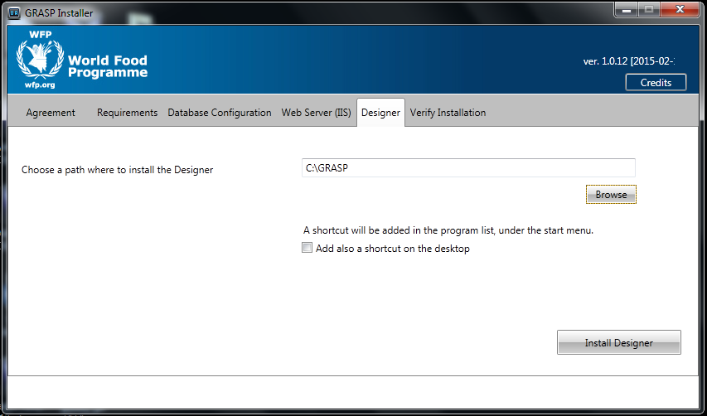

1. A shourtcut will be added in the start menu program list for GRASP Designer, if you want also to add a desktop shourtcut, check the desktop shoutrcut checkbox.
2. Click on “**Install Designer**” button, wait a while, then a popup message will appear to confirm you the it has successfully installed.

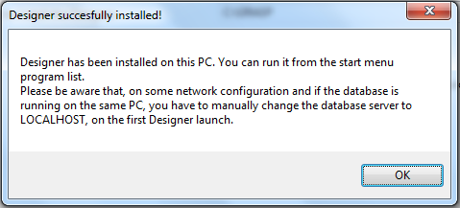

Now, you can find that GRASP Designer is added to the start menu, and a desktop shortcut is created (in case if you have checked the checkbox).

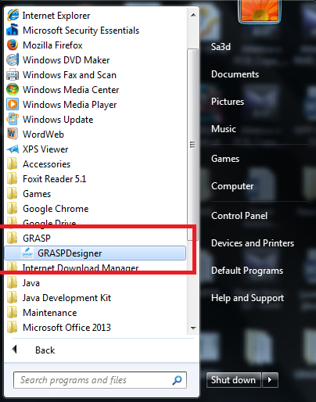



**Note:** after you open the GRASP Designer the first time, a folder named **“FrontlineSMS”** will be created under your user account folder. Please, don’t delete or modify that folder.

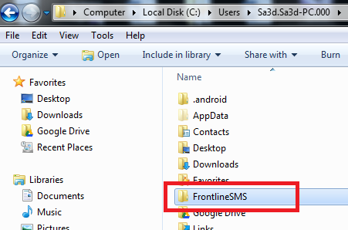

## ***3.7 Verify GRASP Installation***

1. Now, you have finished the GRASP installation, go to **Verify Installation** tab to test the GRASP Reporting.

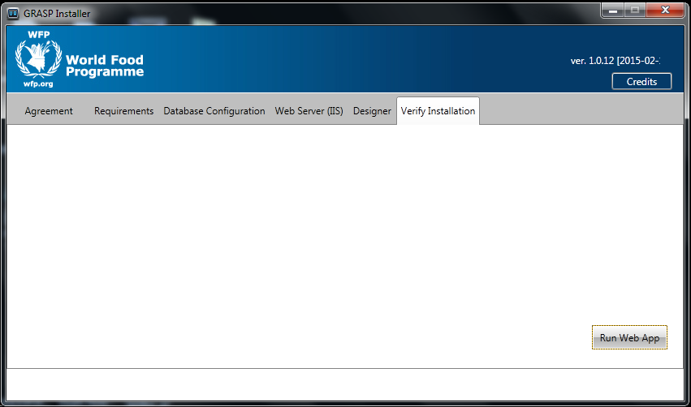

1. Click on **“Run Web App”** to verify that the GRASP Reporting is working fine.
2. Congratulations ☺, you have finished installing the new GRASP successfully, click on close button to close the installation.

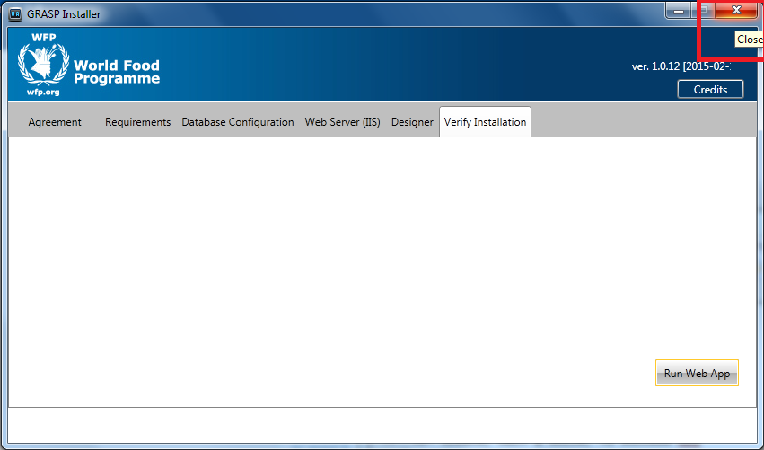

## ***3.8 Run GRASP Designer System***

1. To start GRASP Designer, click on the GRASPDesiger in start menu, or double click on the desktop shortcut.
2. A popup will show and then another login popup, enter the user name (“admin”) and password (“admin”), and click OK.

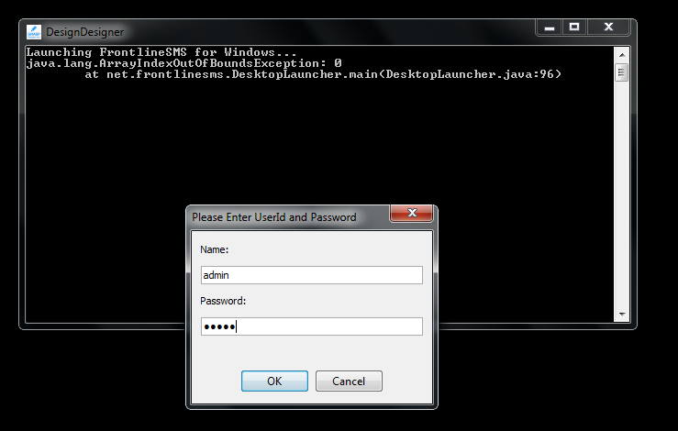

1. If this is the first time you run GRASPDesigner, another popup appear to select the language, and then a second popup “First-time Wizard” click on **Start Design Tool** button.

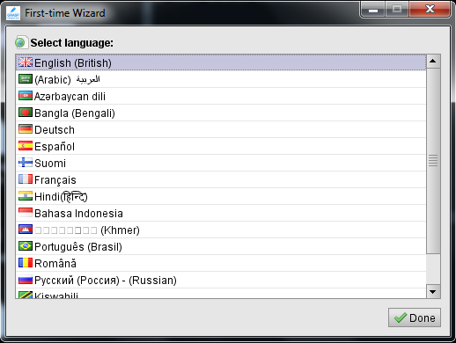

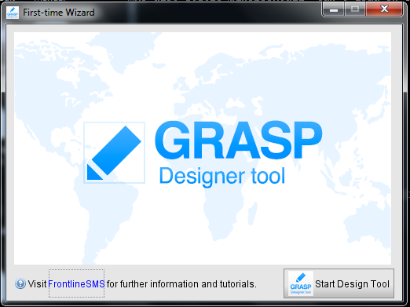

1. Now, the GRASPDesigner starts, and you can start working.

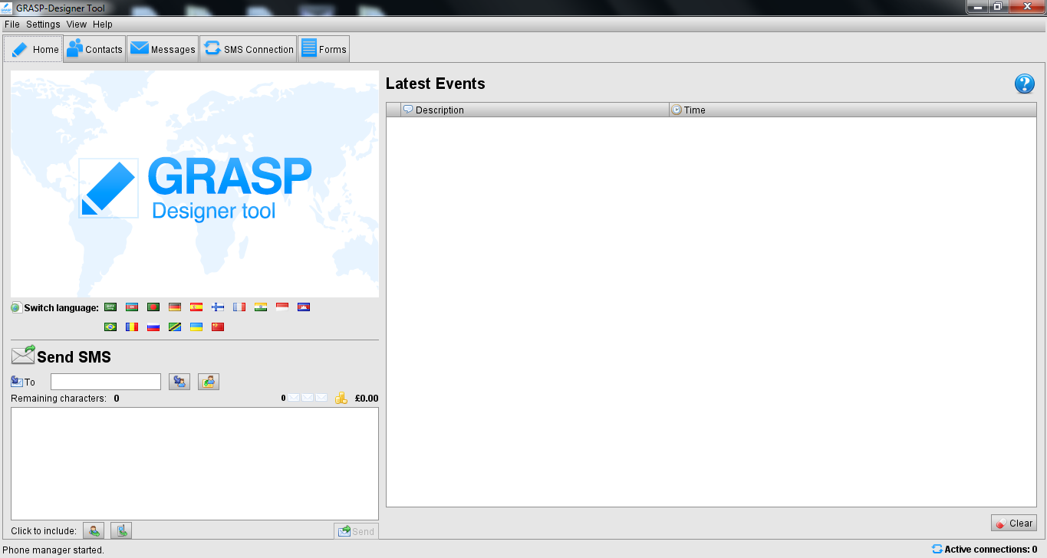

## ***3.9 Install GRASP Mobile***

To install GRASP Mobile, following the following steps:

1. Download GRASP Mobile APK, there are two options:
   1. Option 1: Download GRASP Mobile APK from PC:
      1. Connect the mobile to computer using the USB cable (the mobile phone should be switched on).
      2. Windows Explorer of the mobile will open automatically or you will have to open it from **My Computer**.
      3. Open the GRASP Reporting, and click on the **“Download GRASP Mobile APK”** link from login or home page, and save the apk file in mobile.

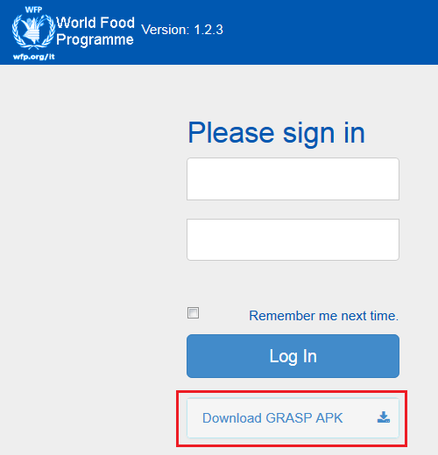

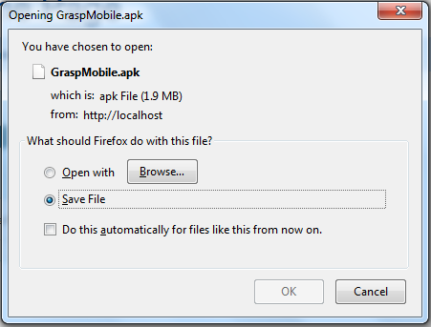

* + 1. Disconnect mobile from Computer.
  1. Option 2: Download GRASP Mobile APK directly from Mobile device, If the mobile device can access the server over the network:
     1. Open web browser and navigate to GRASPReporting URL.
     2. Click on the **“Download GRASP Mobile APK”** link from login or home page, and save the apk file to mobile.

1. Open the **GraspMobile.apk** file.
2. If your phone is set to block installation of apps obtained from unknown sources, you will see the following popup message. Click on **Settings** button.

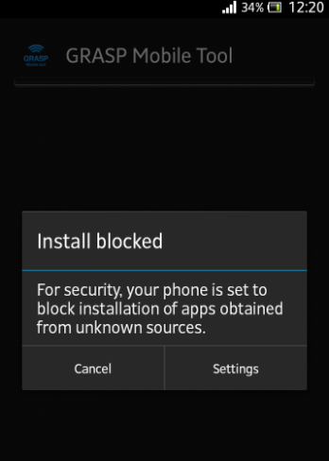

1. Check the **Unknown sources** check box.

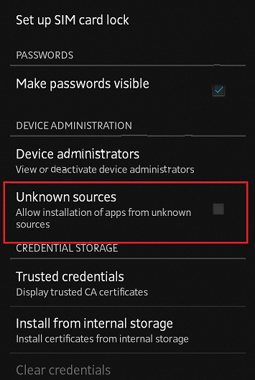

1. Go back, and open **GraspMobile.apk.**
2. Now you will be able to install GRASP Mobile app.
3. Click **install**.
4. After installation is finished, for your phone security, don’t forget to return to Settings -> Security -> and uncheck **Unknown sources** check box.
5. Open GRASP Mobile app.
6. Click on **SETTINGS** button, to set the settings for the first time to connect to your server.

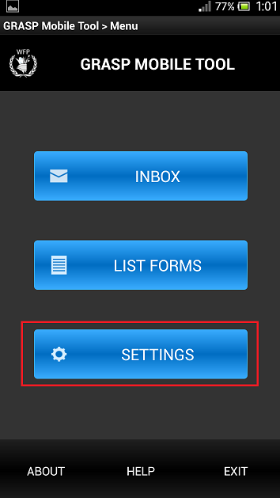

* 1. Enter the setting’s password which is “**brains**”.

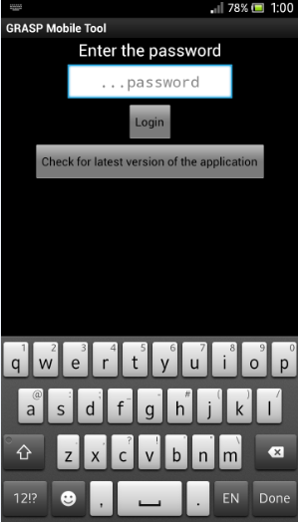

* 1. Now, fill the following settings in order to connect to the server (GRASP Reporting).

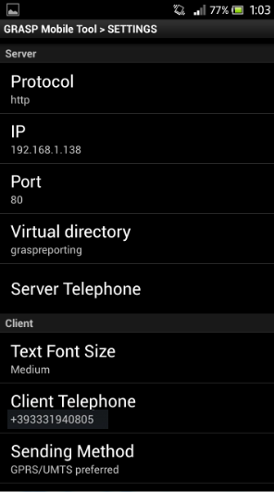

* + 1. In **Protocol** setting, select **http** value.
    2. In **IP** setting, enter the server IP address.
    3. In **Port** setting, enter the GRASP Reporting application port number. The default number is **80**.
    4. In **Virtual directory** setting, enter the virtual directory name of the GRASP Reporting application. The default name is **graspreporting**.
    5. In **Client Telephone** setting, enter your phone number of the SIM card used in your phone.
    6. In **Sending Method** setting, there are three options:
       1. **GPRS/UMTS preferred**: it is the default option which means that mobile try to connect to server via WIFI if there is no WIFI, it asks the user if he wants to send via SMS.
       2. **GPRS/UMTS Only**: WIFI only and no SMS sending.
       3. **SMS Only**: the app will not check the WIFI connection, it will always send via SMS.
       4. **Server Telephone**: is the phone number of the server (only for SMS transmission). This will be set automatically if the mobile receives a form via SMS.
    7. Click on **Check Server Connection** to check if the mobile could connect to server.

# **APPENDICES**

## ***APPENDIX 1: Install Microsoft .NET Framework***

GRASP Installer requires .NET framework to run. If MS .NET Framework is not installed on your server, and try to run GRASP Installer, you will see the below error message.



To install MS .NET Framework, follow the following steps:

1. Navigate to Google.com web site.
2. Search about **download .net framework**.
3. Download .NET Framework 4.0 or above.
4. Run the exe file and follow the wizard.
5. After finishing the installation, try to run the GRASP Installer again.

## ***APPENDIX 2: Install JAVA Version 7***

GRASP Designer requires JAVA version 7 to run. If JAVA version 7 is not installed on your server, then when you are in the **“Requirements”** tab, and click on **“Start System Requirement Check-up”** button, you will see the below message.





To install JAVA version 7, follow the following steps:

1. Navigate to Google.com web site.
2. Search about **download java 7**.
3. Download the Java 7 edition for your server operating system (for example Windows x64).
4. Run the exe file, and follow the setup wizard.
5. After finishing the installation, try to click on **“Start System Requirement Check-up”** button again.

## ***APPENDIX 3: Enable Microsoft SQL Server TCP/IP protocol***

By default, the installation of MS SQL Server do not enable TCP/IP protocol to other applications. In that case, if you click on **Auto-Discover** button, GRASP Installer will show a messagae says **“No Microsoft SQL has been found!”.**



To enable TCP/IP protocol, follow the following steps:

1. On the Start menu, choose All Programs, expand **Microsoft SQL Server**, expand **Configuration Tools**, and then click on **SQL Server Configuration Manager**.

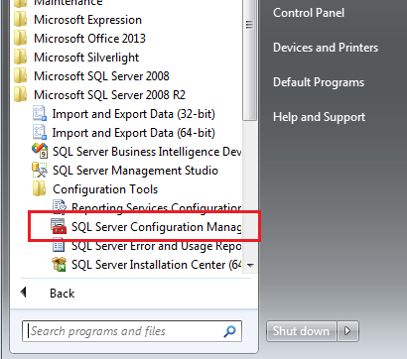

1. Expand **SQL Server Network Configuration**, and then click on **Protocols for [InstanceName]**, where InstanceName could be “**SQLEXPRESS**”, “**MSSQLServer**” or instance name used during installation of SQL Server.

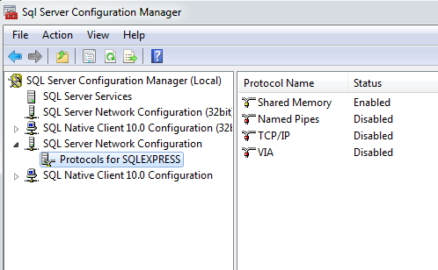

1. In the list of protocols, double click on **TCP/IP** protocol. In the **Protocol** tab, select **Yes** for the **Enabled** feature.

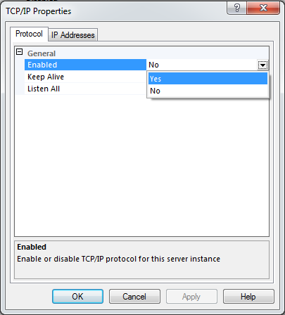

1. Go to **IP Addresses** tab, scroll down to the **IPAll** configurations, and set the **TCP Port** for example to the default one **1433**.

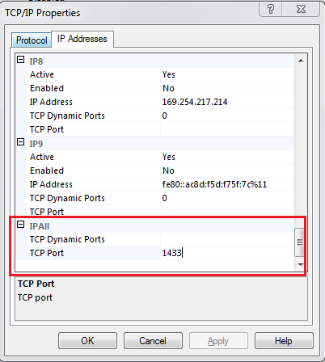

1. If the **TCP Dynamic Ports** box contains **0**, indicating the Database Engine is listening on dynamic ports, delete the **0**.
2. Click **OK** to confirm the changes.
3. In the left pane, select **SQL Server Services**. Then in the right panel, right-click on **SQL Server ([Instance Name])** service, and click **Restart** or **Start** if it is not started.

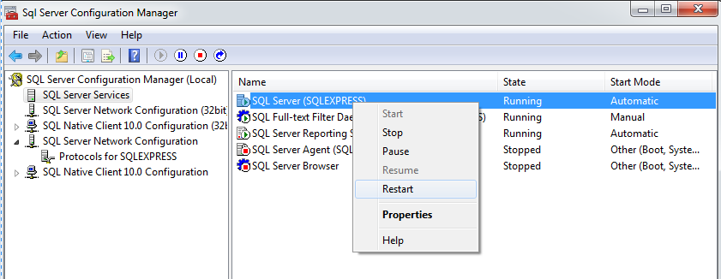

1. Optional Step: to confirm the correct installation of all SQL Server features try to lunch “**sqlcmd**” command form commands prompt. It should recognize the “sqlcmd” command from any location, if not please reinstall management studio with all features.
2. Click on **Auto-Discover** button again, if GRASP Installer still show the same message **“No Microsoft SQL has been found!”**, try to start the **SQL Server Browser** service.

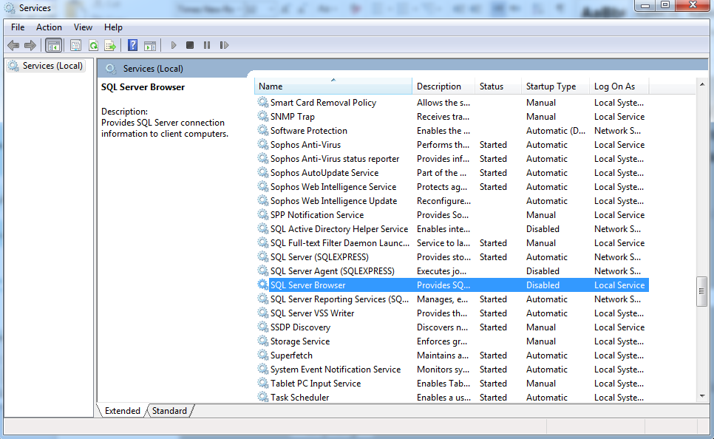

## ***APPENDIX 4: Move GRASP Reporting Location Path***

Since GRASP Reporting system is the server side system which includes the **GRASPImage** and **ResponseFiles** folders where the server saves all the images and forms sent from mobile devices or uploaded via Reporting. Therefore, after a while the GRASPReporting folder may become large, and you may want to move it to another location. And, it is a good practice to get a **backup** of the GRASP Reporting folder and GRASP database from time to time.

Follow the following steps to change the GRASP Reporting location path:

1. Move the GRASPReporting folder to the new location.
2. Open IIS Manage.
3. In the left pane, select **GRASPReporting** application.
4. In the right pane, click on **Basic Settings**.
5. In the Edit Application dialog, change the **Physical path** from the old path to the new path.
6. Click on **OK** button.

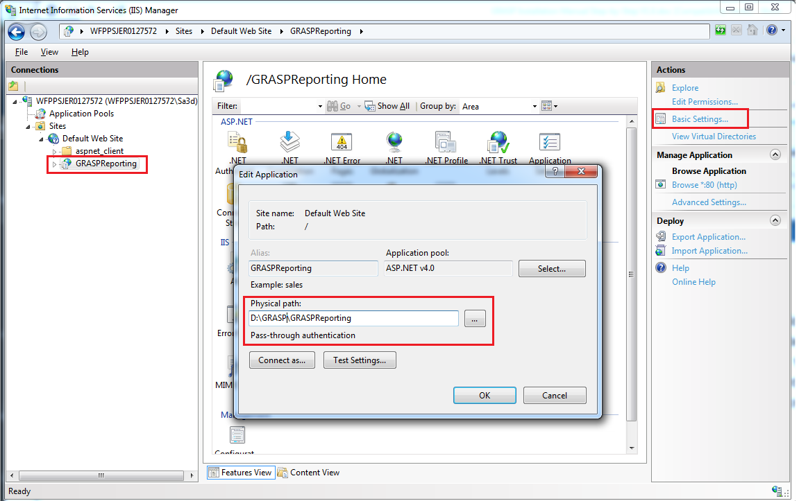

1. Set folder permission for IUSR, please refer to **APPENDIX 8: Set Folder Permissions for IUSR**.
2. Now, you need to manually edit some properties in the **web.config** file under GRASPReporting folder.
   1. Open **Web.Config** file under GRASPReporting folder.
   2. Find the **GRASPReportingPath** property and change it to the new path, and make sure to keep a **slash \** at last.

<add key="GRASPReportingPath" value="D:\Projects\GRASPReportingPal\" />

* 1. Find the **ResponseFilesFolderPath** property and change it to the new path, and make sure to keep the ResponseFiles\ at last.

<add key="ResponseFilesFolderPath" value="D:\Projects\GRASPReportingPal\ResponseFiles\" />

* 1. Save and close the file.

1. Now, try to open GRASPReporting.

## ***APPENDIX 5: Enable 32-bit Applications in IIS***

Sometime, when you try to run GRASP Reporting, you sees the following error page:



To solve that error, you have to enable the 32-bit application pool. Please, follow the following steps:

1. Open IIS Manager.
2. In the left pane, select **GRASPReporting** web application. Then in the righ pane, click on **Basic Settings**, find the Application pool of it (the default is **DeafultAppPool**).

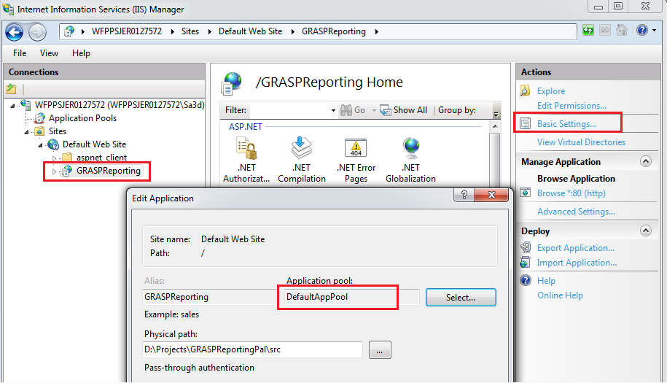

1. In the **“Connections”** left pane, select **“Application Pools”**.
2. In the Application Pools grid, right-click on the GRASPReporting application pool (default is **DefaultAppPool**, sometimes it could be **ASP.NET v4.0**) and click on **“Advance Settings…”** option.

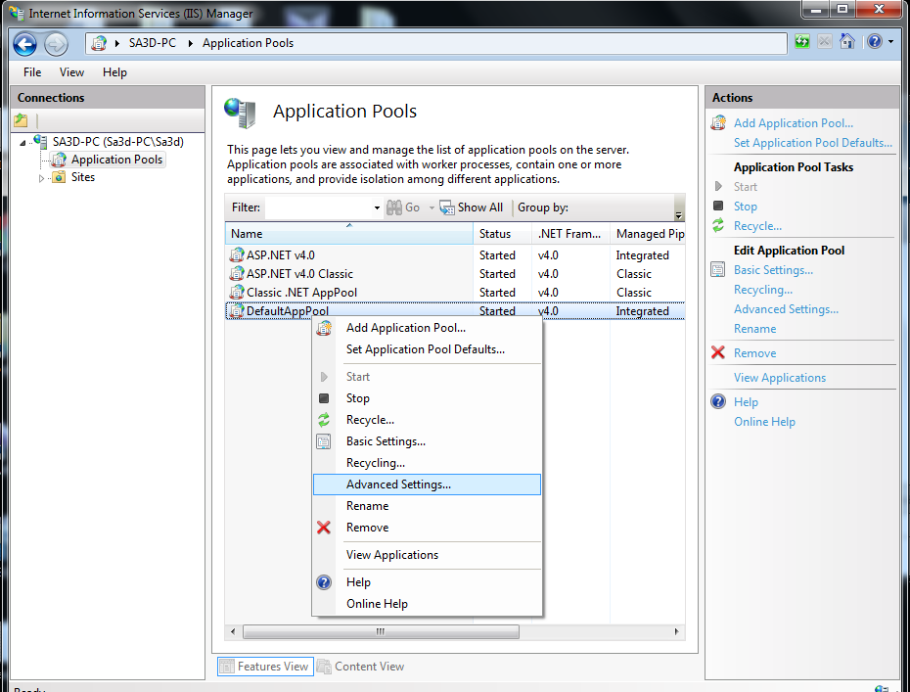

1. Under **“General”** group options, find the **“Enable 32-Bit Applications”** option, and select **True** value, then click on **OK** button.

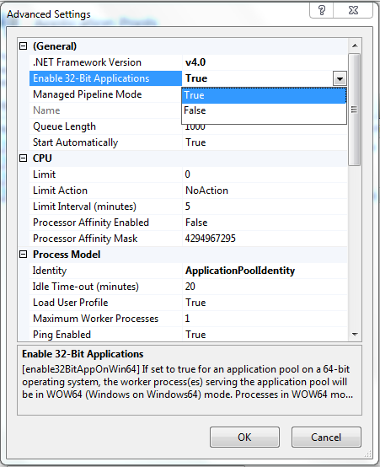

1. Return to the **“Connections”** left pane, select the server name (the root option).
2. To restart IIS, go to the right pane **“Actions”**, click on **“Restart”** button.

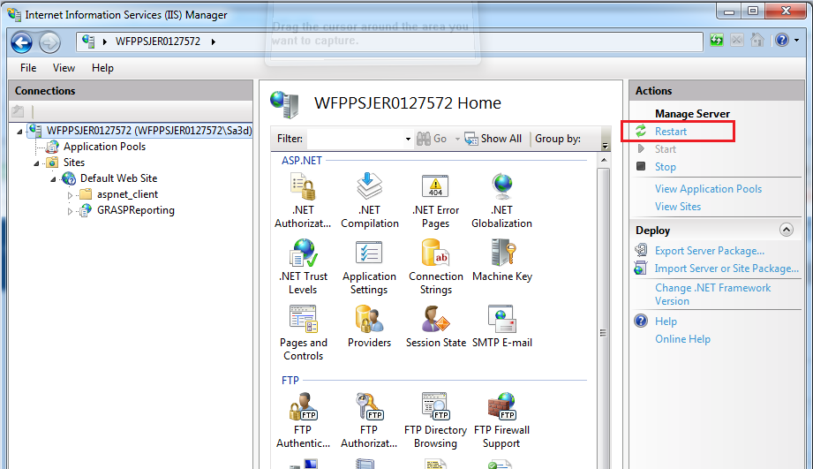

1. Now, try again to access the GRASP Reporting, the problem should be solved.

## ***APPENDIX 6: Open GRASP Reporting Port***

This section explains how to open the GRASP Reporting web application port (default is port 80) on the server, in case that the GRASP Mobile app could not connect to Reporting. The port could be closed from Windows Firewall. So, if you make sure that you have set the GRASP mobile settings correctly to connect to server (IP address, port number, and virtual directory) and still could not connect to server, follow the following steps to open the GRASP Reporting web application port:

1. Open **Control Panel**.

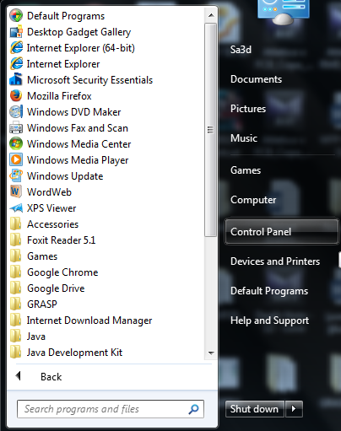

1. Click on **“System and Security”** category.

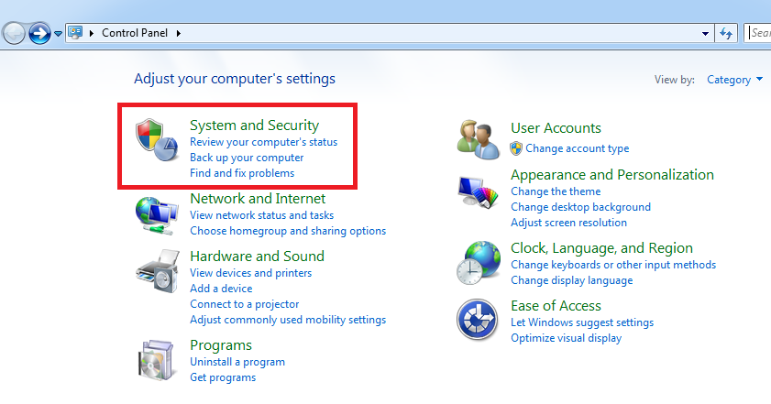

1. Click on **“Windows Firewall”**.

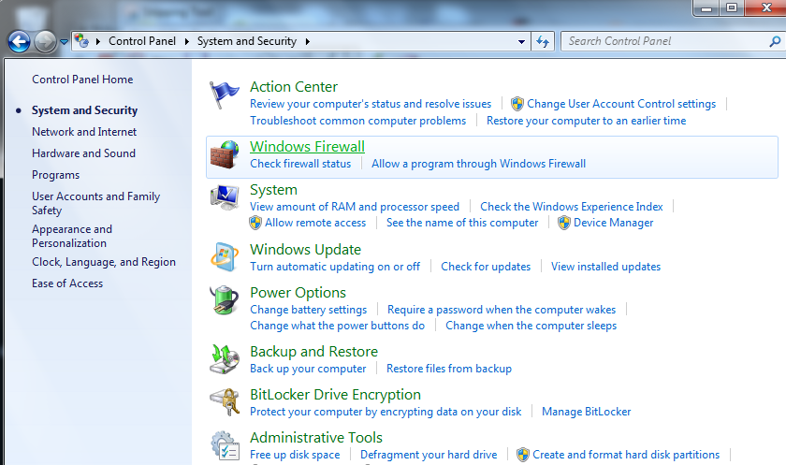

1. From the left pane, click on **“Advance Settings”**.

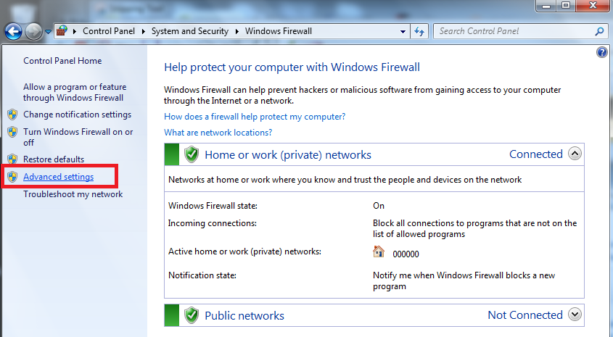

1. From the left pane, select **“Inbound Rules”**.

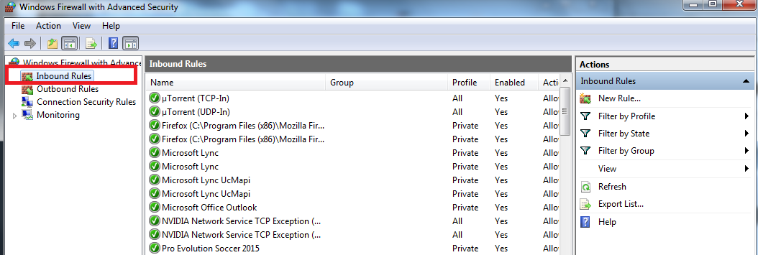

1. In the right pane, click on **“New Rule…”**.
2. Select **“Port”**, and click on **“Next >”** button.

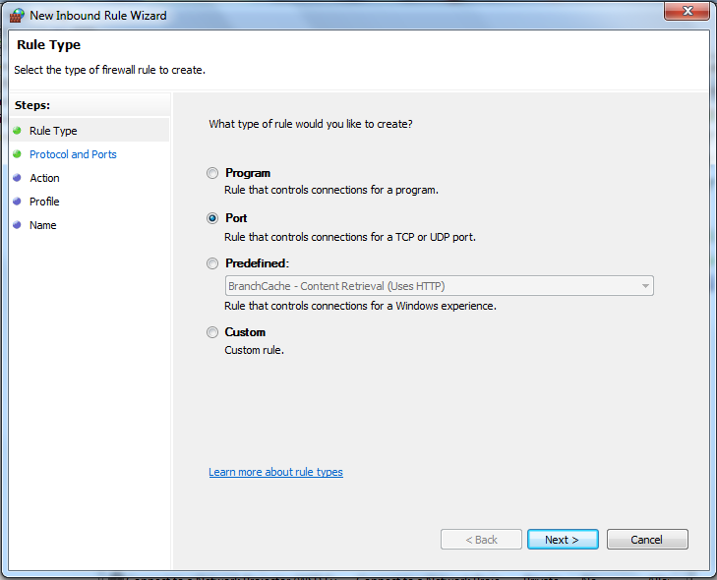

1. In the **“Specific local ports”** field, enter the GRASP Reporting application port number (the default is 80).

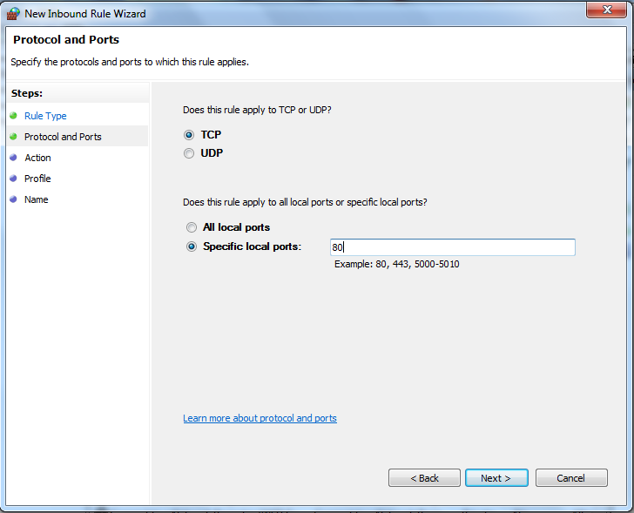

1. Enter a name for the rule (for example: Allow port 80), and click on **“Finish”** button.

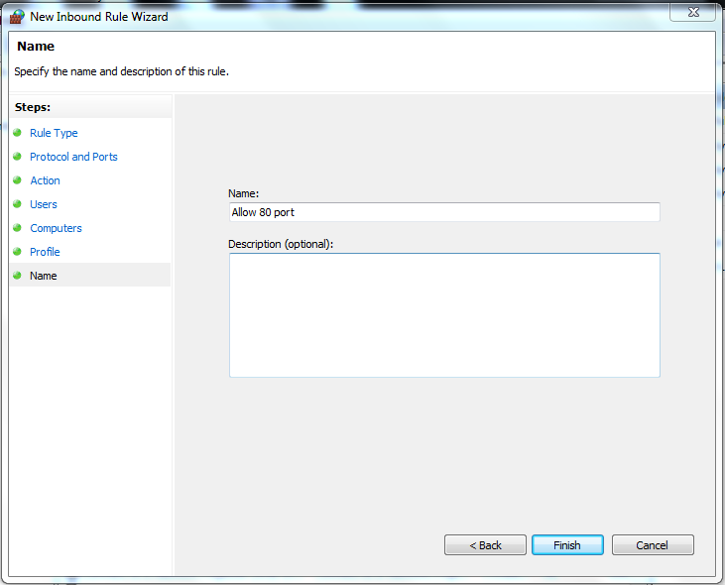

1. Now, you can find the new created rule with a green icon.

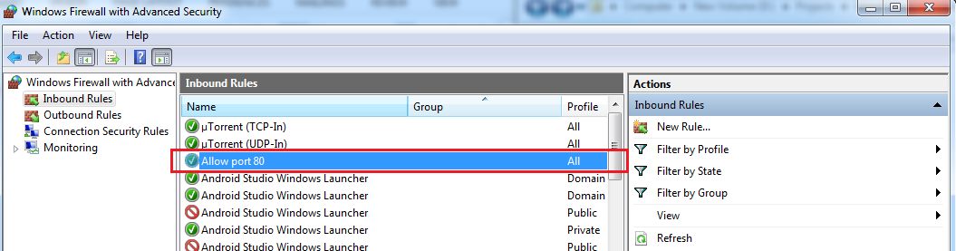

1. From mobile, try to connect to server again.

## ***APPENDIX 7: Install Microsoft SQL Server and Management Studio***

1. Download Microsoft SQL Server 2008 R2 (you can use the free Express Edition) or higher version.
2. During the installation, make sure to select **“Mixed Mode (SQL Server authentication and Windows authentication)”** and enter a password for the **administrator (sa)** account.

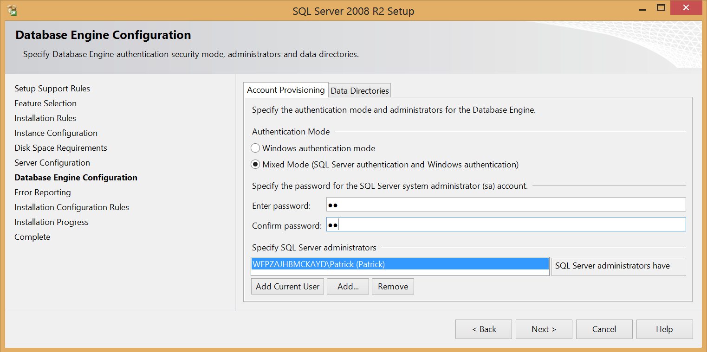

1. Please, contact with your administrator to help you install Microsoft SQL Server 2008 R2 or for more information please visit this link: [How to Install Microsoft SQL Server 2008 R2](https://msdn.microsoft.com/en-us/library/ms143219%28v=sql.105%29.aspx).

## ***APPENDIX 8: Set Folder Permissions for IUSR***

Sometimes, if your IIS server could not write to some folders under GRASP Reporting, file permissions must be set manually on the **GRASP Reporting folder** (or for the following subfolders: **Temp** folder, **Public/InfoHP.txt** file, **GRASPImage** folder, **ResponseFiles** folder, and **LogFiles** folder). The permissions are **Read**, **Write** and **Modify** for the **IUSR** user. Please, contact your administrator for more information or please visit this link: [How to give permissions to folders for IUSR](https://support.gearhost.com/hc/en-us/articles/200342205-How-to-give-write-access-to-files-for-IUSR).

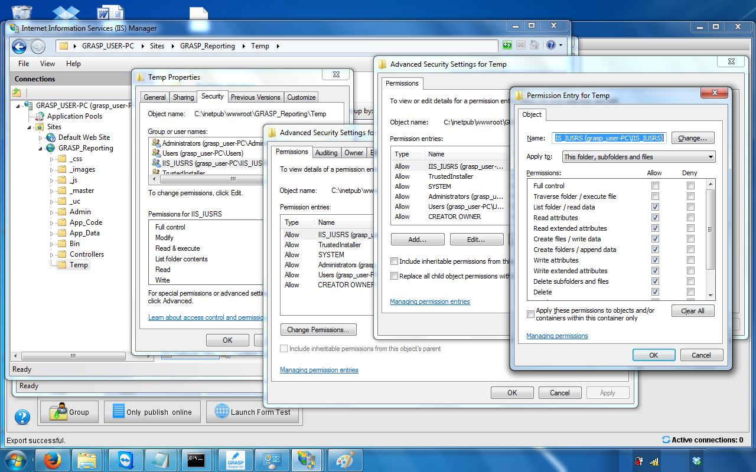

## ***APPENDIX 9: Change GRASP Reporting Web Configuration file Properties***

GRASP Installer automatically set all properties in Web.Config file of GRASP Reporting. However, later you may want to change some settings, this appendix describes how you can change some of the GRASP Reporting settings in the Web.Config file. Below is a list of the main settings in Web.Config, you can find the property by search about it using its name:

1. **GRASPReportingVirtualDirectoryName** property: this property defines the the virtual directory name of GRASP Reporting in IIS web server. In case you want to rename that virtual directory or manually create a virtual directory with a different name than GRASPReporting (the default name), then you have to change the value of this property.

<add key="GRASPReportingVirtualDirectoryName" value="GRASPReporting" />

1. **IsGRASPImagesFolderNotUnderReportingFolder** property: this property defines whether the GRASPImage folder is located under the GRASP Reporting folder (default) or not. The default value is "**No**", which means that the GRASPImage folder is located under GRASPReporting root folder, where GRASPReporting deny access to images for unauthorized users (only logged users can access images).

<add key="IsGRASPImagesFolderNotUnderReportingFolder" value="No" />

If you want to move the GRASPImage folder to another location, then you have to change this property to “**Yes**”.

**Important notes for this case:**

1. You will lose the security access on images, where unauthorized users can access images if they could know the image url.
2. If you already saved images in a virtual directory name different that the new name, you will not be able to access the old images through GRASP Reporting, since their path for IIS is no longer available.

And, you have to manually create a separate Virtual Directory for GRASPImage folder (another than the GRASPReporting virtual directory), and set the next two properties: GRASPImagesFolderPath and ImageFolderName.

* 1. **GRASPImagesFolderPath** property: this property defines the new GRASPImage path, for example: D:\.

<add key="GRASPImagesFolderPath" value="D:\" />

* 1. **ImageFolderName** property: this property defines the GRASP Image folder name (in case you want to rename it) for example: GRASPFormImages.

<add key="ImageFolderName" value="GRASPImage" />

1. **ImagesFileType** property: this property defines the image file type in server, where the GRASP Reporting receves images from mobile devices and can save them in another image type, for example: .jpg (the default type).

<add key="ImagesFileType" value=".jpg" />

1. To change **GRASPReportingPath** and **ResponseFilesFolderPath** properties, please refer to **APPENDIX 4: Move GRASP Reporting Location Path**.
2. **Connection strings**: to change the connection string settings to connect to the GRASP database server, you have to change the underlined text (specially **user id** and **password**) in the following two connection strings:

<add name="GRASP_MemberShip" connectionString="Data Source=.\SQLExpress;initial catalog=GRASP;Integrated Security=False;user id=sa;password=root;" providerName="System.Data.SqlClient" />

<add name="GRASPEntities" connectionString="metadata=res://*/App_Code.GRASP.csdl|res://*/App_Code.GRASP.ssdl|res://*/App_Code.GRASP.msl;provider=System.Data.SqlClient;provider connection string=&quot;data source=.\SQLExpress;initial catalog=GRASP;integrated security=False;user id=sa;password=root;MultipleActiveResultSets=True;App=EntityFramework&quot;" providerName="System.Data.EntityClient" />